Threat Modelling details process:
1. Spoofing (S)
- Where: Policy Holder login, Agent login
- Justification: Unauthorized users may impersonate legitimate users using stolen credentials.
- Mitigation: Implement multi-factor authentication (MFA), CAPTCHA, and account lockout after failed attempts.
2. Tampering (T)
- Where: Agent submits policy details, Document uploads
- Justification: Malicious actors could alter policy or claim data during submission or upload.
- Mitigation: Use secure transmission protocols (HTTPS), digital signatures, and integrity checks.
3. Repudiation (R)
- Where: Claim filing, Policy submission
- Justification: Users may deny having submitted a claim or policy, leading to disputes.
- Mitigation: Maintain detailed audit logs with timestamps and user IDs; use non-repudiation mechanisms.
4. Information Disclosure (I)
- Where: Diagnostic Reports, Document Handling
- Justification: Sensitive medical and personal data could be exposed to unauthorized parties.
- Mitigation: Encrypt data at rest and in transit, enforce strict access controls, and apply data masking.
5. Denial of Service (D)
- Where: Authentication System, Company Backend
- Justification: Attackers could flood login or submission endpoints, making the system unavailable.
- Mitigation: Apply rate limiting, load balancing, and anomaly detection for traffic spikes.
6. Elevation of Privilege (E)
- Where: Company Backend, Document Handling
- Justification: Users may exploit vulnerabilities to gain higher access rights (e.g., agents approving claims).
- Mitigation: Enforce role-based access control (RBAC), conduct regular privilege audits, and apply least privilege principle.

Trust Boundaries
- Between Policy Holder/Agent and Portal: External users interacting with system interfaces.
- Between Portal and Backend Systems: Internal data processing and decision-making.
- Between Backend and Document Handling: Sensitive data storage and retrieval.

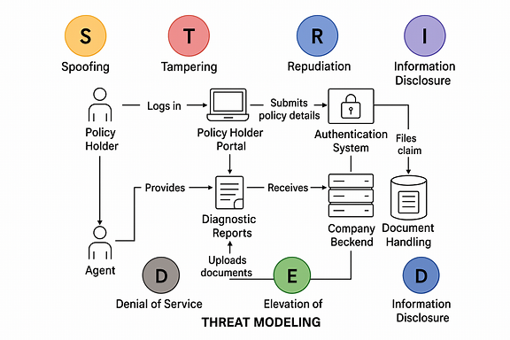

- Policy Holder Portal → Risks: Spoofing, Information Disclosure
- Agent Portal → Risks: Tampering, Repudiation
- Company Backend → Risks: Elevation of Privilege, DoS
- Document Handling → Risks: Tampering, Data Leakage
- Authentication System → Risks: Spoofing, DoS

